MIDTERM EXAM

Date assigned: March 8, 2019
Date due: March 15, 2019

Each problem: 5 points
Total exam: 15 points (15% of course grade)

Problem 1: Basic NMR

A) What magnetically active nucleus generates the signal we detect to make a typical MR image? (1 point)

B) The gyromagnetic ratio of carbon-13 is 10.7 MHz/T. What is the resonant frequency of ¹³C at 3 Tesla? How does this compare to the resonant frequency of ¹H at 3 Tesla? (1 point)

C) In a static magnetic field oriented along the positive z- axis, what is the orientation of the net magnetic moment of a spin isochromat at equilibirum? (1/2 point)
After application of a (perfect) inversion pulse, what is the orientation of the net magnetic moment of the isochromat? (1/2 point)

D) After application of a 90_{y} degree excitation pulse (rotating M away from equilibrium, clockwise around the y-axis):

What is the orientation of the net magnetic moment, M? (1/3 point )

What is the relative magnitude of the longitudinal magnetization, M||, if M (the length of M) is 10 units? (1/3 point)

What is the relative magnitude of the transverse magnetization, M⊥(again, if M is 10 units)? (1/3 point)
E) After a 30 degree excitation pulse is applied to an isochromat at equilibrium, what are the relative magnitudes of M|| and M⊥? (1 point)
Problem 2: Relaxation

A) Label, on the drawing below, the T₂ and T₂* envelopes describing the magnitude of the net transverse magnetization generated by a collection of spin isochromats in an inhomogeneous magnetic field environment during a spin echo experiment. (1 point)
Refocusing pulse
Excitation pulse
Echo
S
M_{T}

Read-out

B) In the inversion-recovery experiment illustrated below, what would be the appropriate time to apply an excitation pulse if you want to acquire an image with the signal from the gray matter nulled? (1 point)
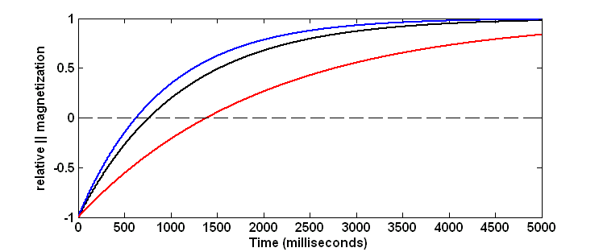
Gray matter
CSF
White matter

C) In the data shown above, which has the longest T₁: gray matter, white matter or CSF? (1 point)

D) In the acquisition described in (B) (TI set to null gray matter), what would be the relative image intensities of white matter and CSF in a magnitude image? (1 point)

E) In any experiment, if the repetition time is very short, should the flip angle of the repeated RF pulse be large or small if you want to maximize image SNR? Why? (0.5 points for right answer; 0.5 points for explanation)

Problem 3: Pulse sequences

A) If a 45 degree RF pulse with 2 kHz bandwidth is applied in conjunction with a linear magnetic field gradient on the x-axis with a strength of 11.7 mT/m, what is the resulting slice thickness? (3/4 point).
What is the orientation of the resulting slice – sagittal, axial or coronal? (1/4 point)

B) What is the read-out direction in the MP-RAGE image below (up/down or front back)? Name 2 clues you can use to figure that out. (1 point total)

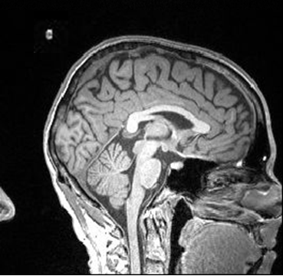
C) Label the slice-select, read-out, and phase-encode gradient axes for the two pulse sequences illustrated below. Describe each pulse sequence as FLASH or EPI, Spin Echo or Gradient Echo. (2 points total - 1/6 each for gradient labels, 1/4 for each FLASH vs. EPI, and 1/4 for each SE vs. GE)

Pulse sequence 3.C.1: _________________________________________

RF

G______

G______

G______

ADC

Pulse sequence 3.C.2: _________________________________________

G______
G______
G______
ADC
RF

D) Draw on the grid provided below the k-space trajectory for the pulse sequence in 3.C.2. Make sure to label the phase-encode direction. (It might help to number the gradients to match k-space excursions; no need to be precise once you get to the read-out lines.) (1 point)

Extra Credit (1 point). For the EPI images shown below, indicate which was acquired with a spin echo pulse sequence, and which was acquired with a gradient echo pulse sequence. Assume both had the same echo time during the acquisition.
Sequence 3.C42.2
